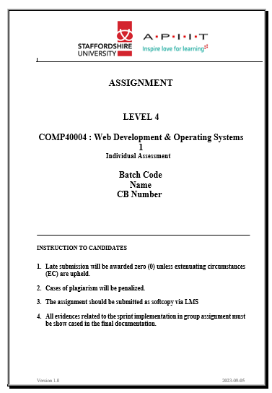

CF23A1COM , FATHIMA AMRAH IMRAN, CB014021

**SRI LANKAN WILDLIFE WEBSITE PROJECT**

**Link for the website-**

https://amrah077.github.io/WILDLIFE-IN-SRI-LANKA-2024/

REPORT

**Learning experience :** This project gave me the opportunity to put into practice every concept and designing feature I learnt in HTML and CSS. I discovered how crucial it is to properly organise web content in order to build an interface that is user-friendly. Understanding the essentials of responsive design was vital for ensuring the website's compatibility with a range of devices and improving accessibility for a larger user base. I encountered numerous challenges and learned a lot while using HTML and CSS to create a wildlife website.

**Challenges and overcoming challenges :** Making sure the CSS styling fit all size ranges within the media query for both mobiles and desktops. And changing certain styling to adapt accordingly. For instance , using flex box on desktop and not using it on mobile. - Adopting a mobile-first approach from the outset facilitated a smoother responsive design implementation.

Maintaining a consistent look for the first 5 webpages. – testing each page numerous times side by side to remove any inconsistencies to ensure the webpage designs are related to each other.

Creating simple animations for the Yala and Wilpattu webpages- watched Youtube videos on how to create subtle animations using CSS only.

**VALIDATION OF HTML AND CSS PAGES**

# Index.html – page1

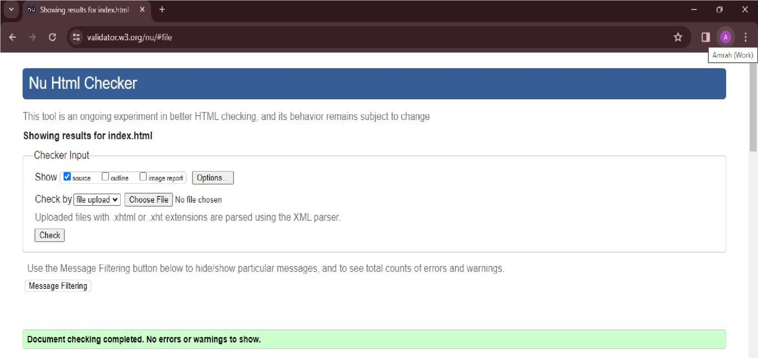

# wildlifeintroduction.html- page 2

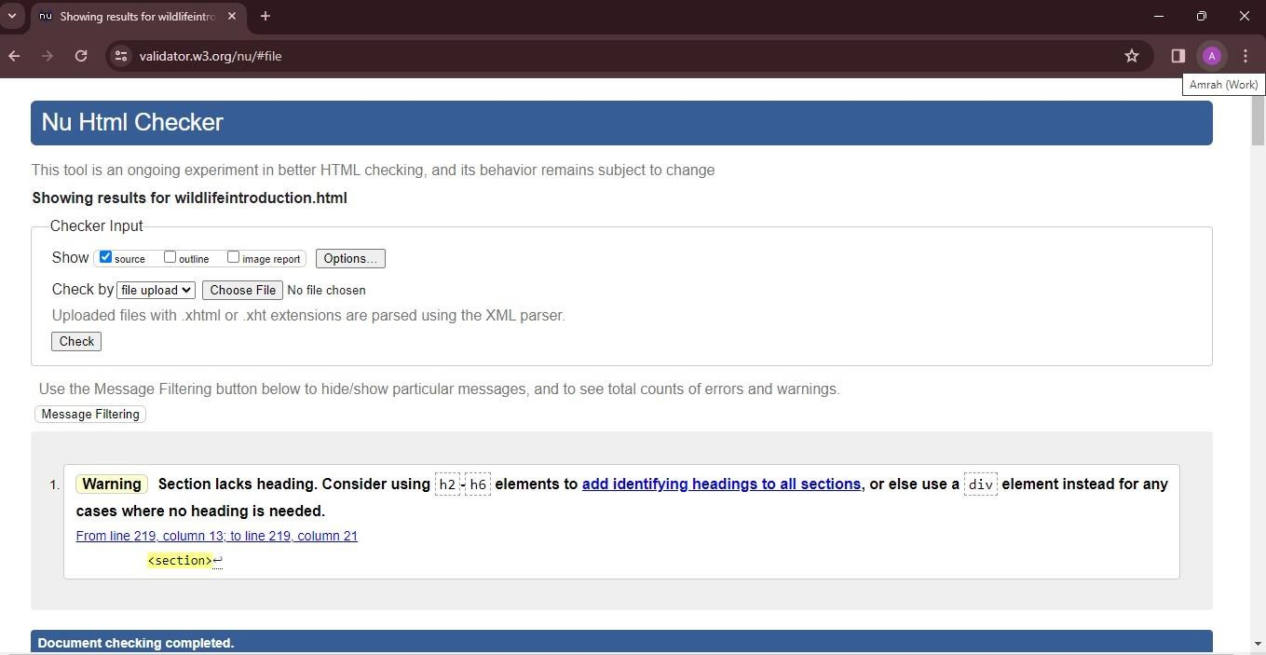

# depwildlifecon.html – page3

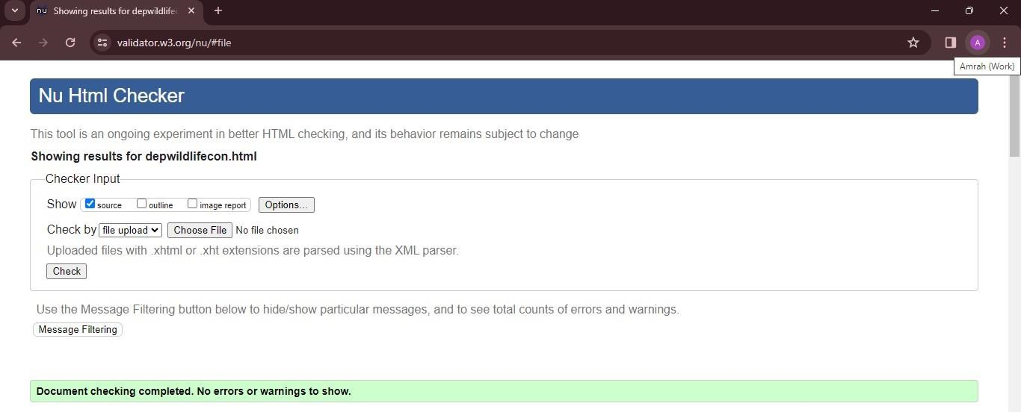

leopard.html – page 4

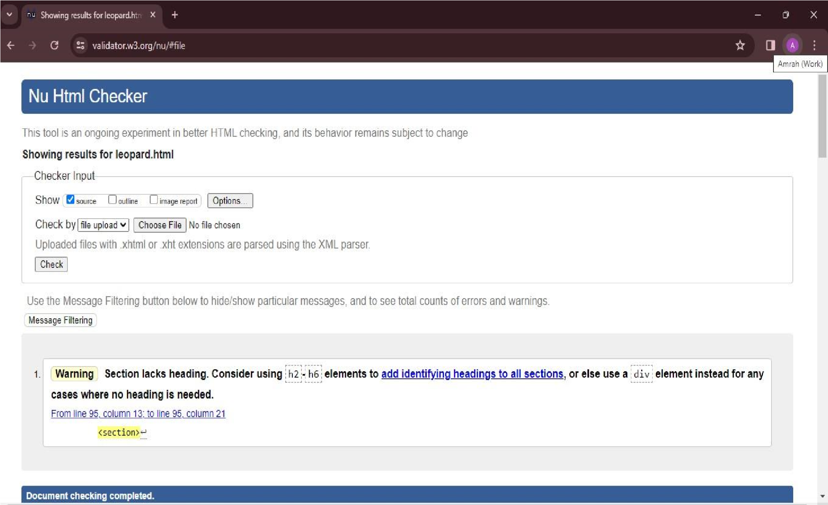

# animalsinsrilanka.html – page 5

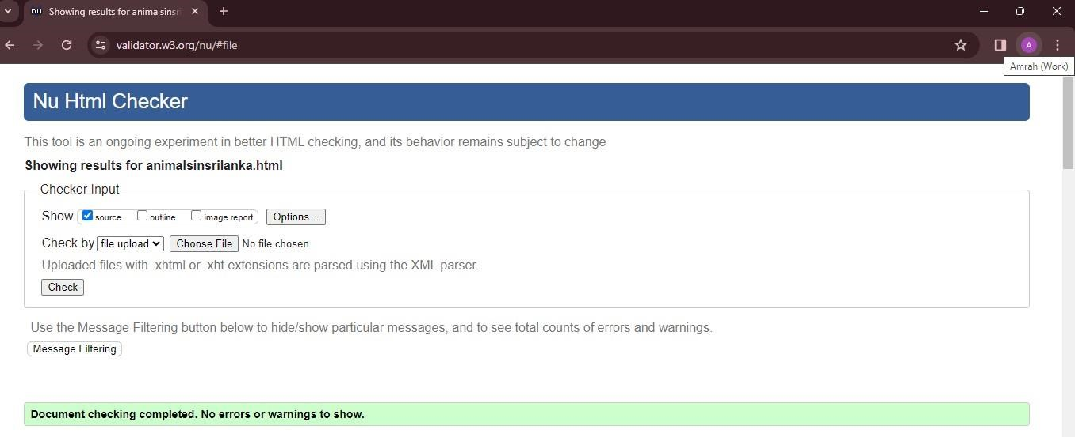

# yalapark.html- page 6

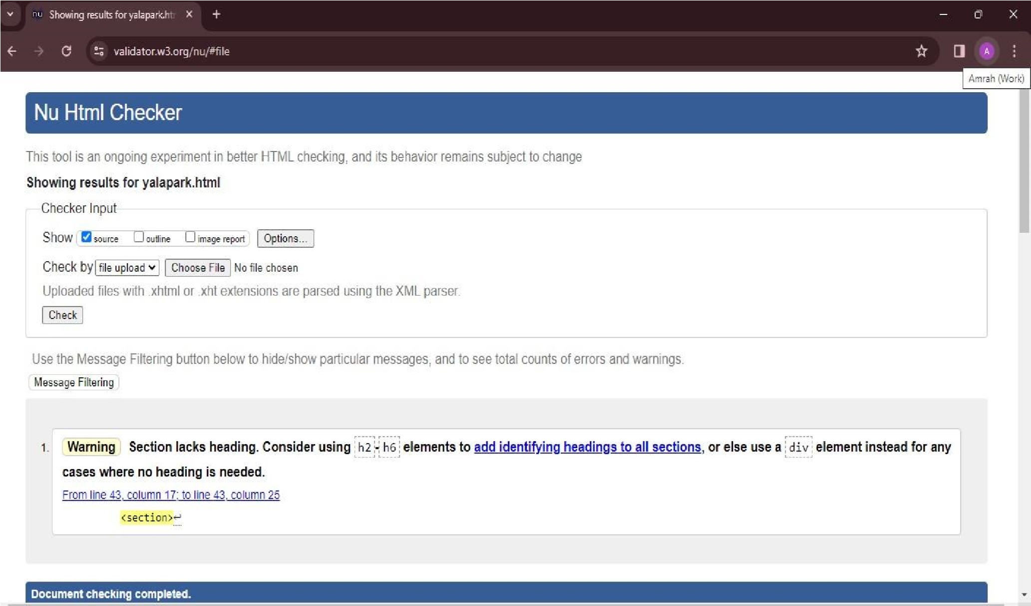

# wilpattupark.html- page 7

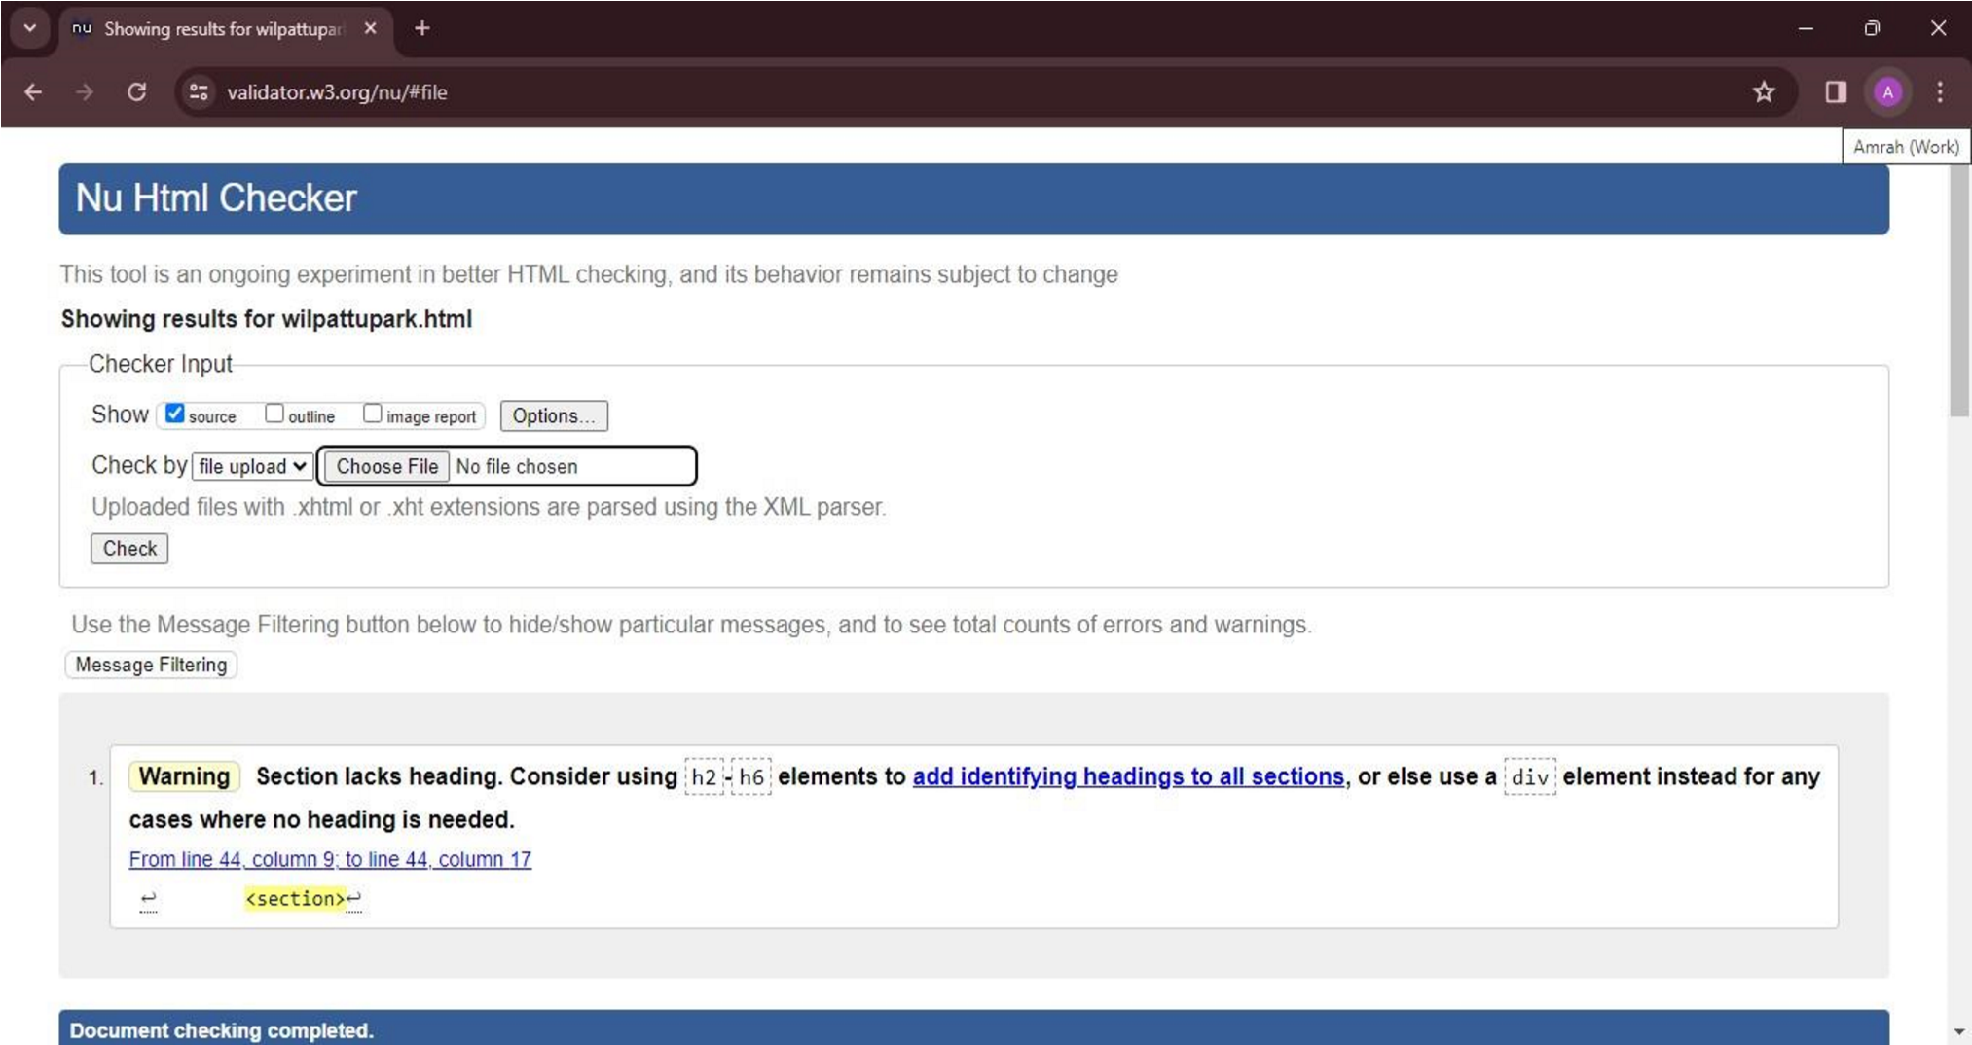

homepage.css

–

CSS for first 5 webpages

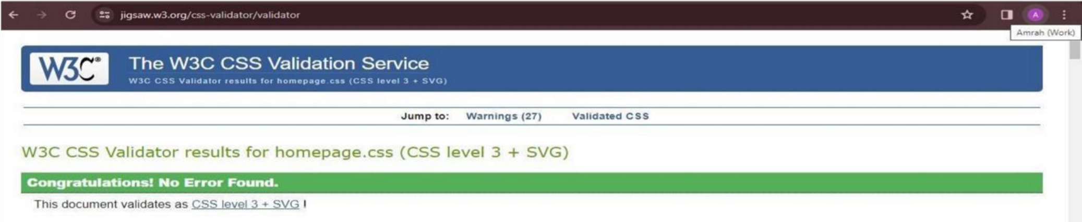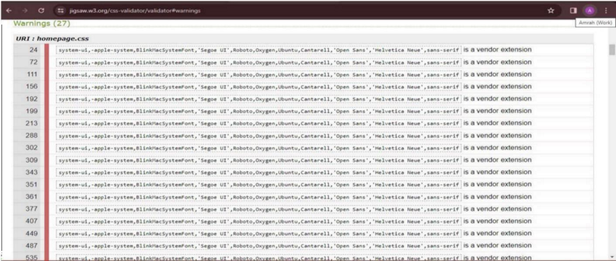

# yalacss.css – css for page 6

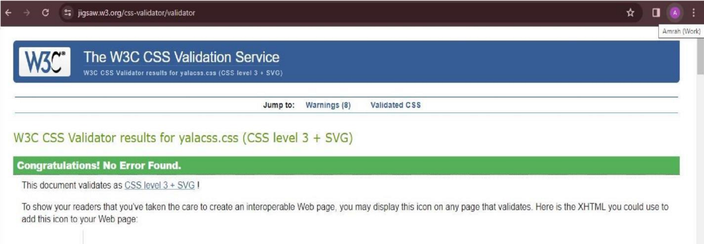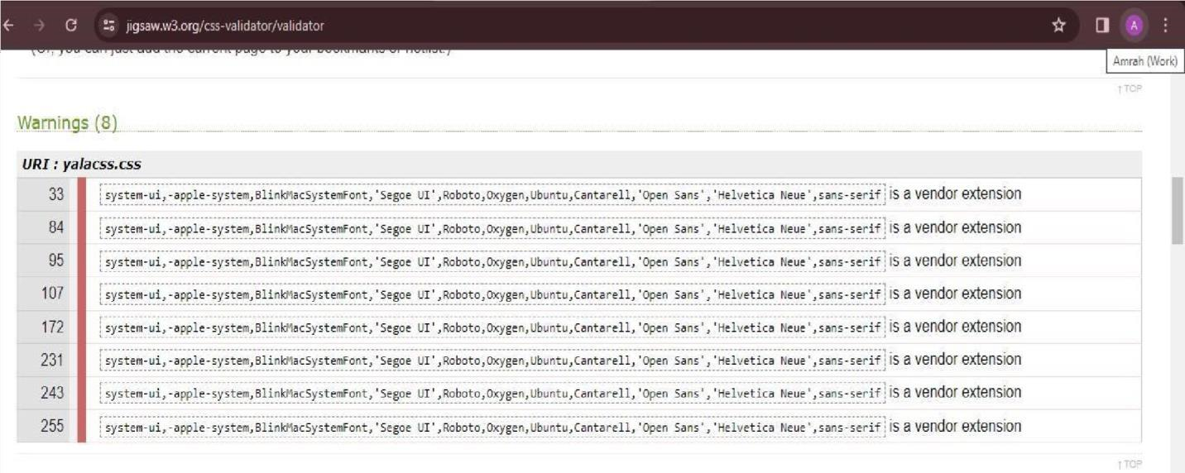

wilpattucss.css

-

CSS for page 7

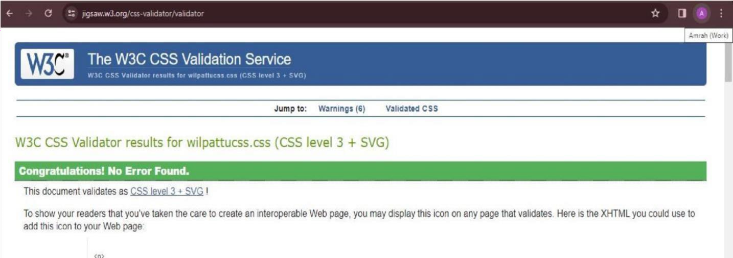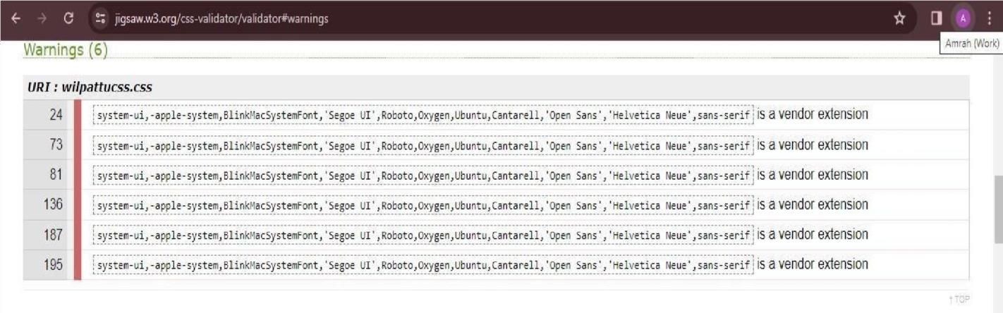

**WIREFRAMES- DESKTOP DESIGN**

index.html – page 1

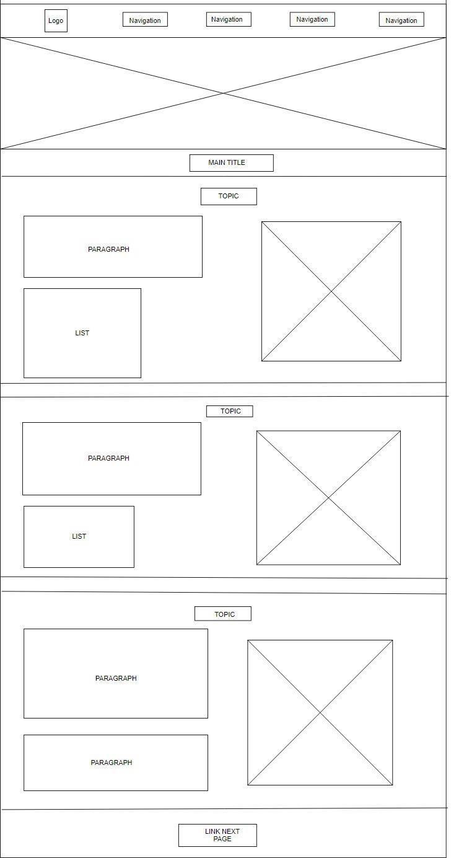

wildlifeintroduction.html – page 2

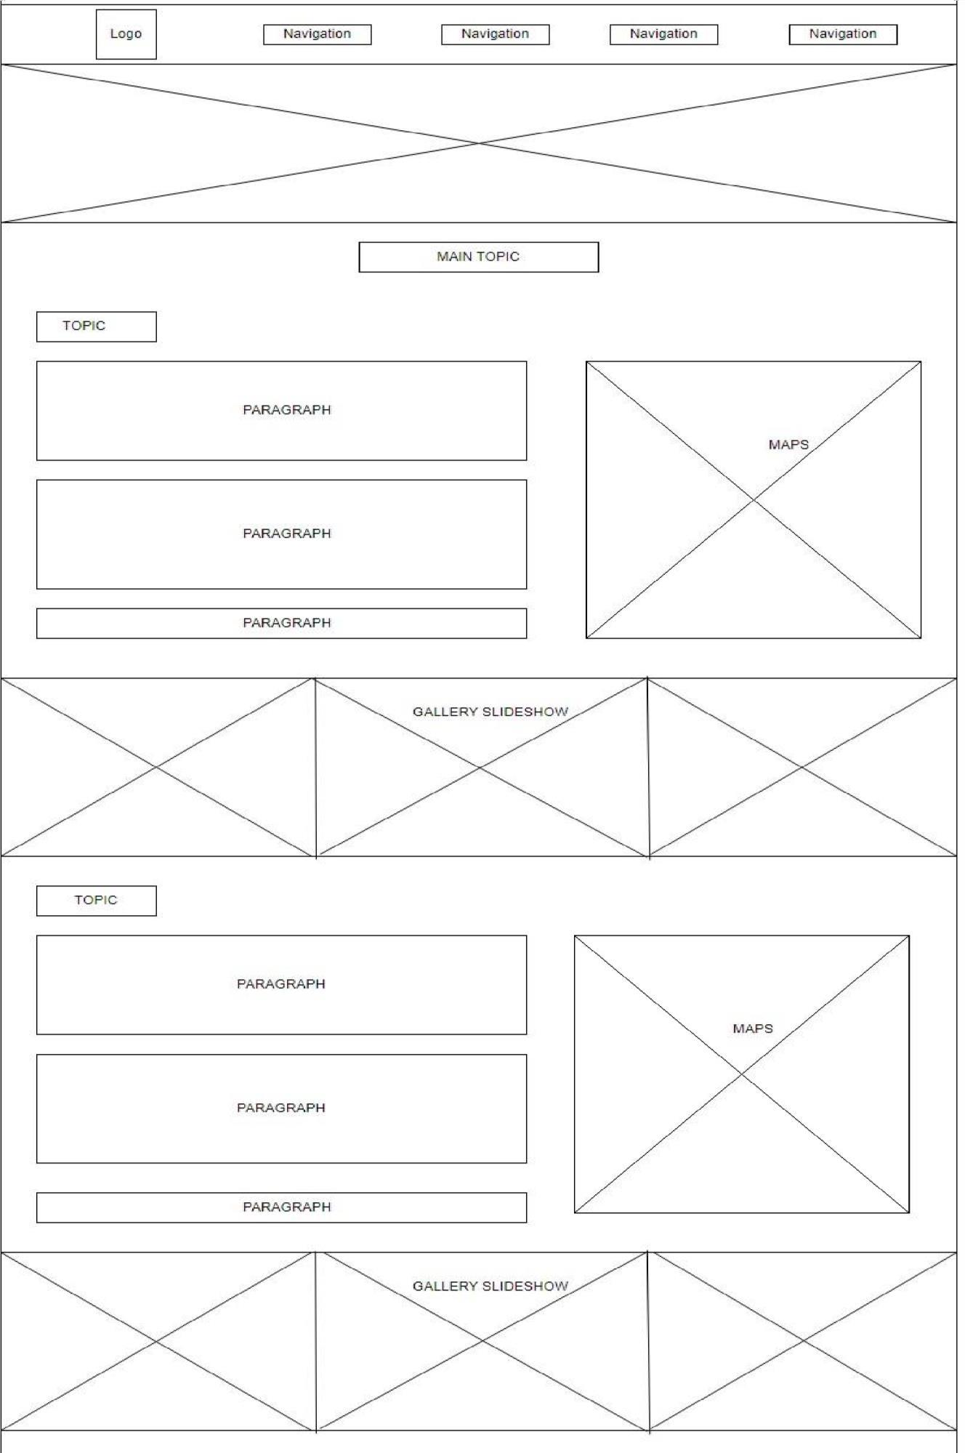

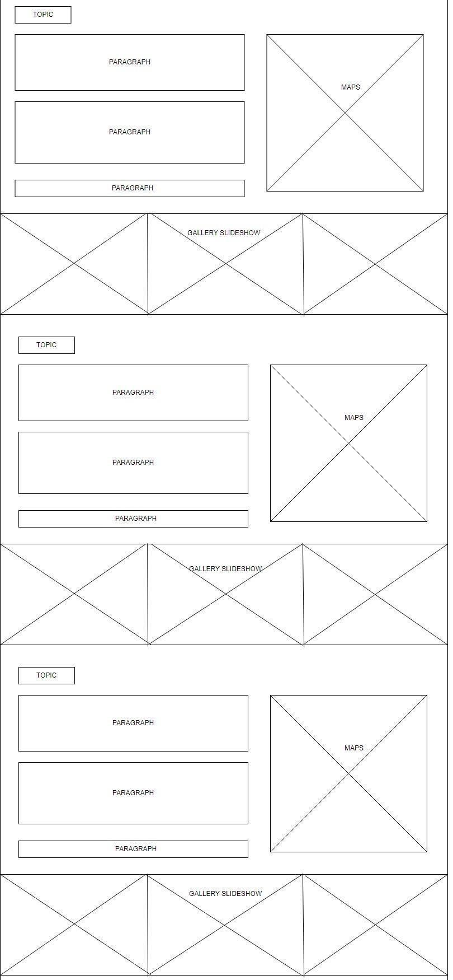

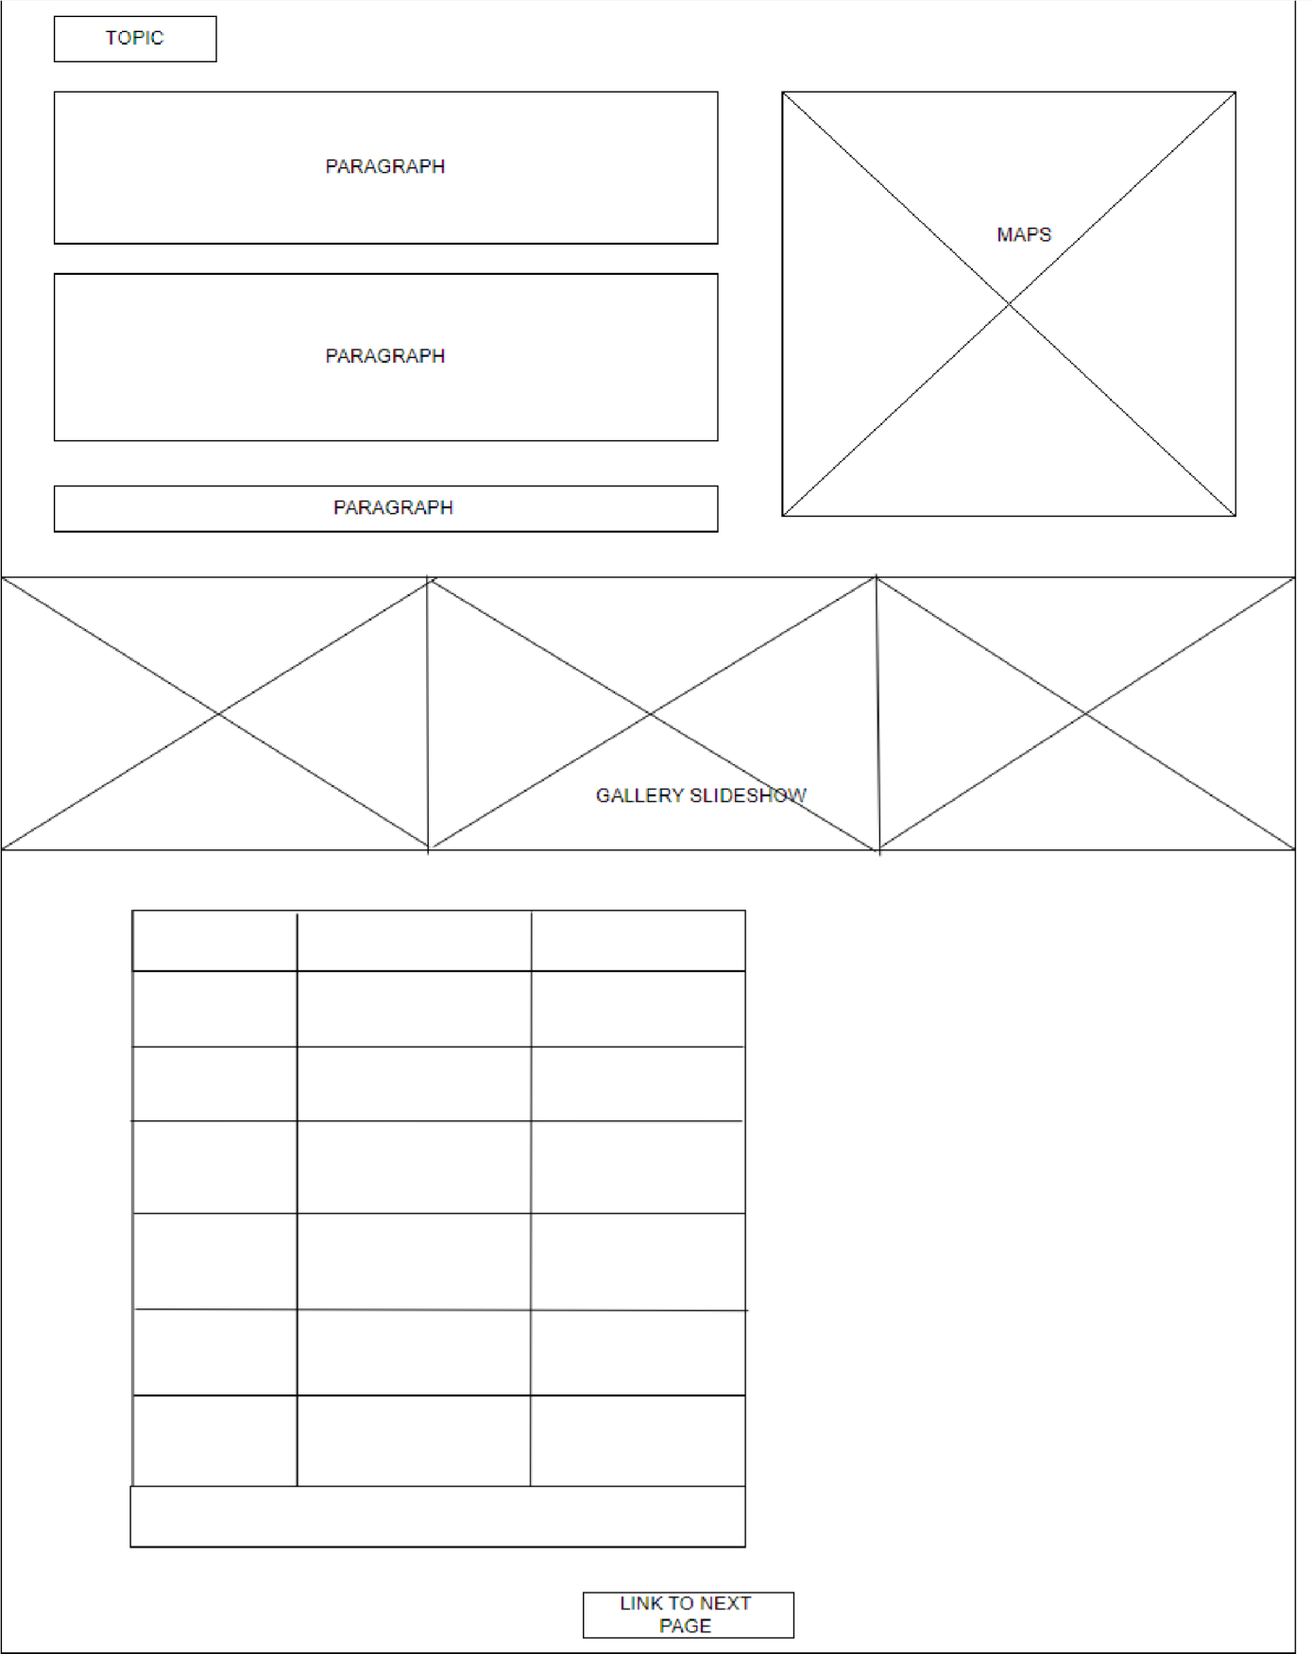

# depwildlifecon.html – page 3

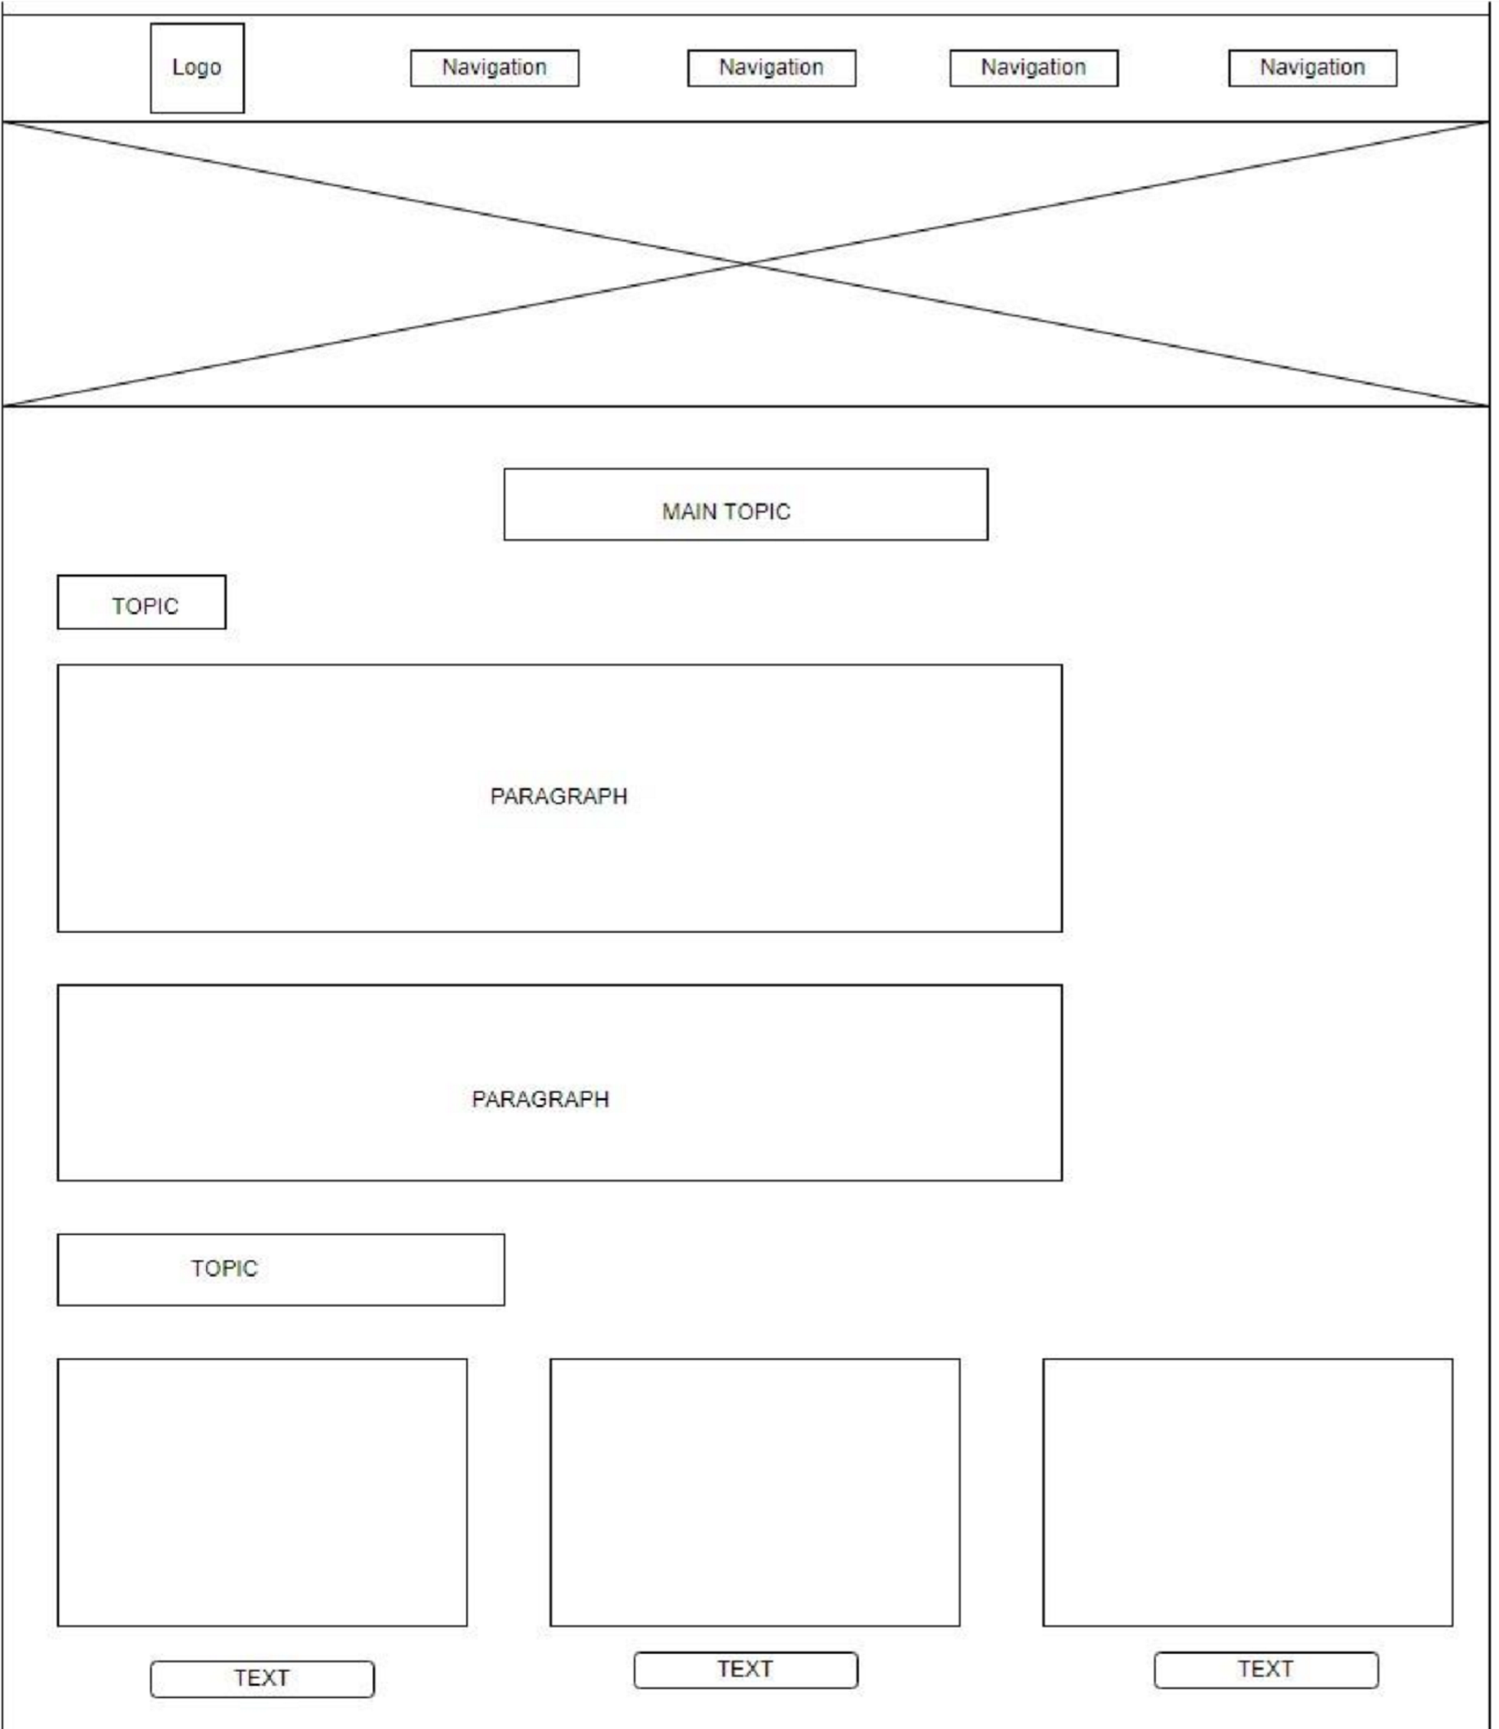

leopard.html

-

page

4

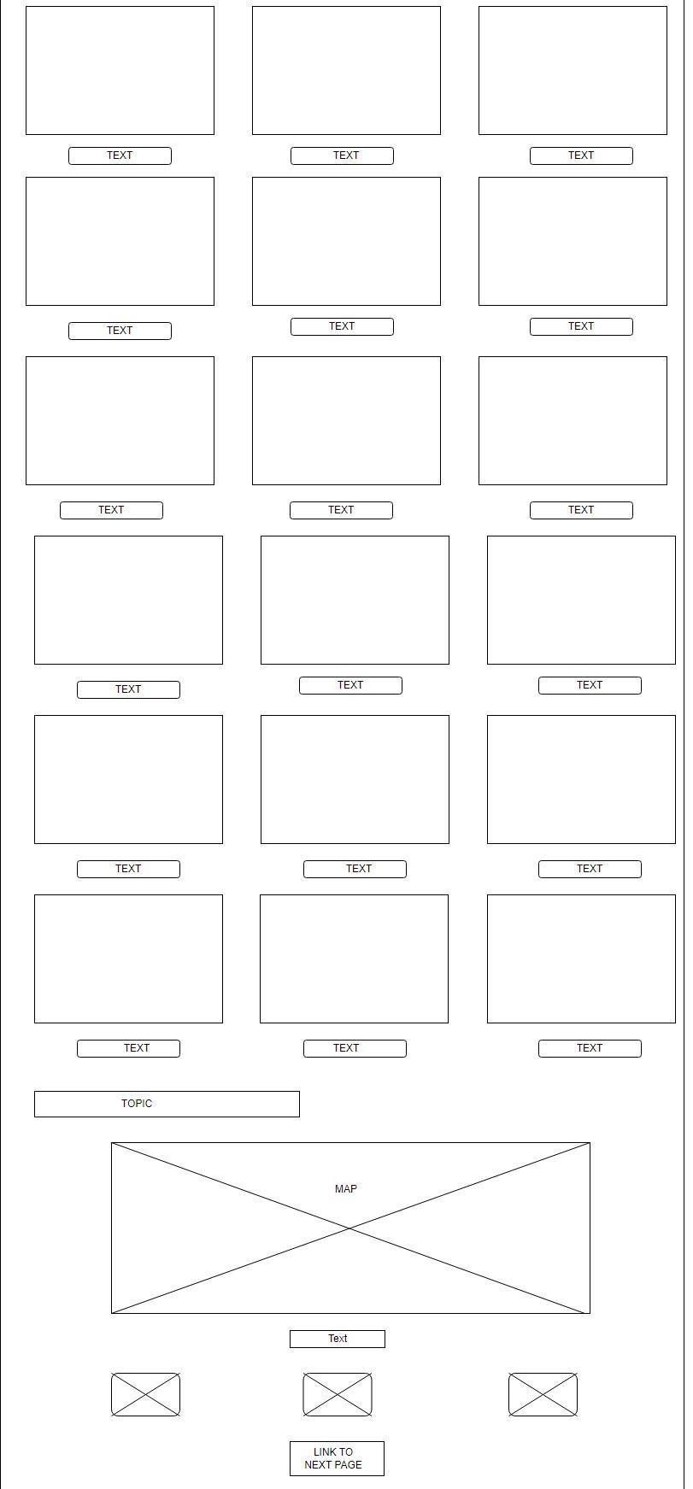

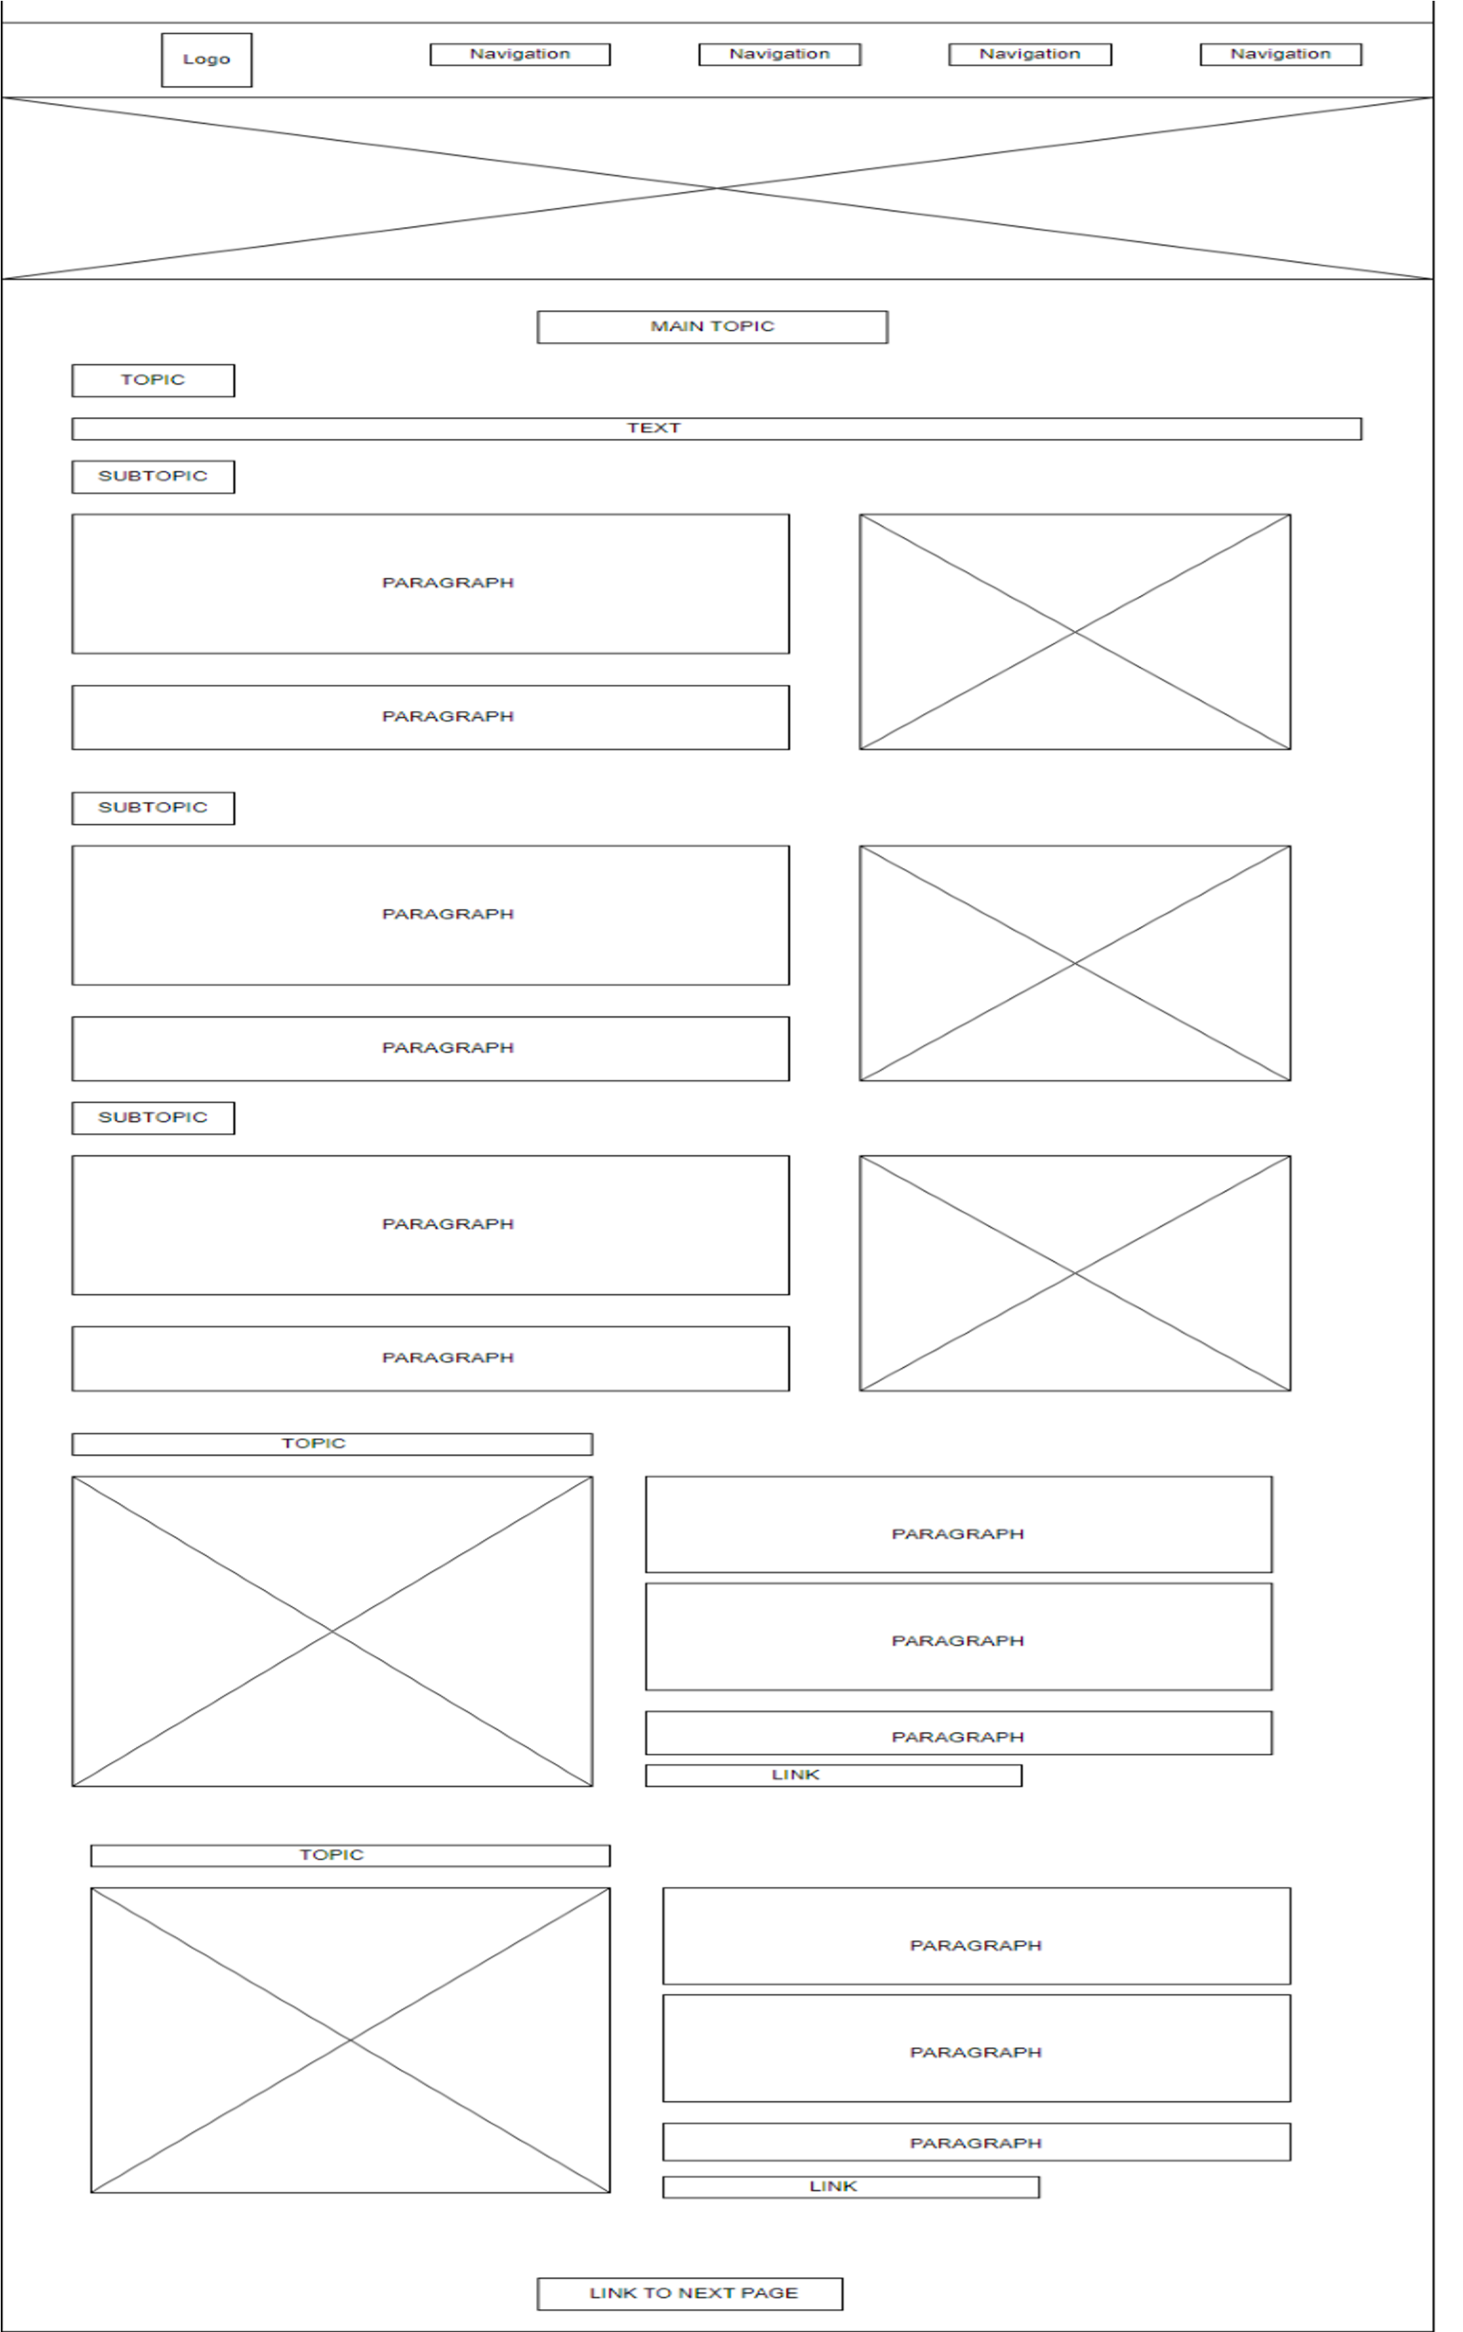

# animalsinsrilanka.html – page 5

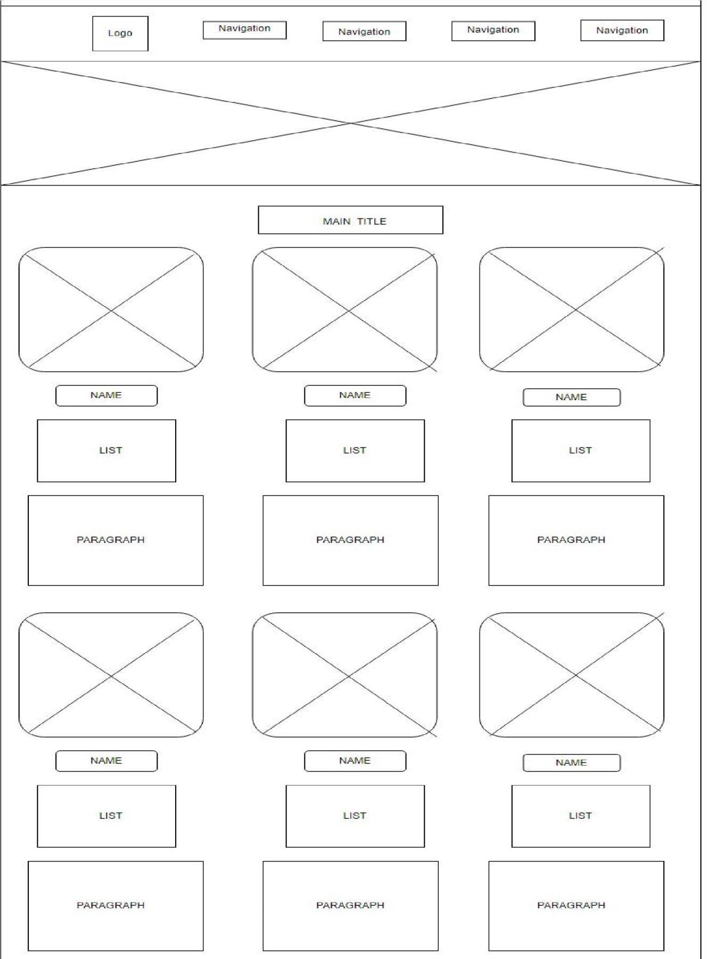

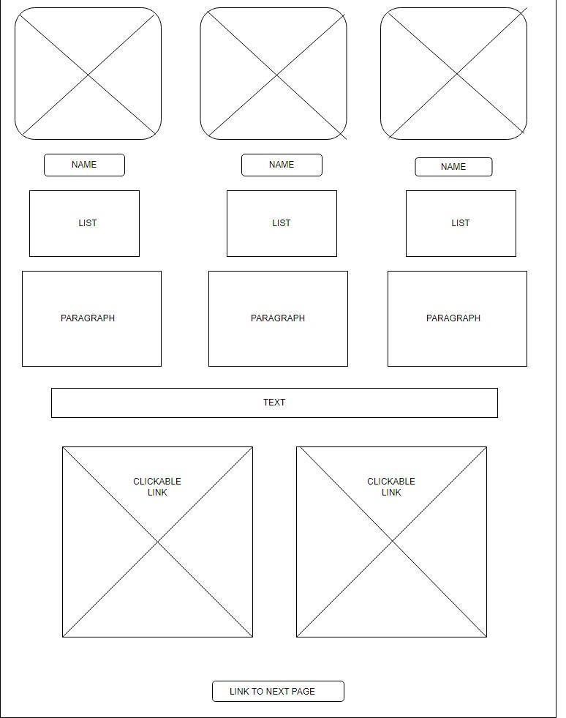

# yalapark.html – page 6

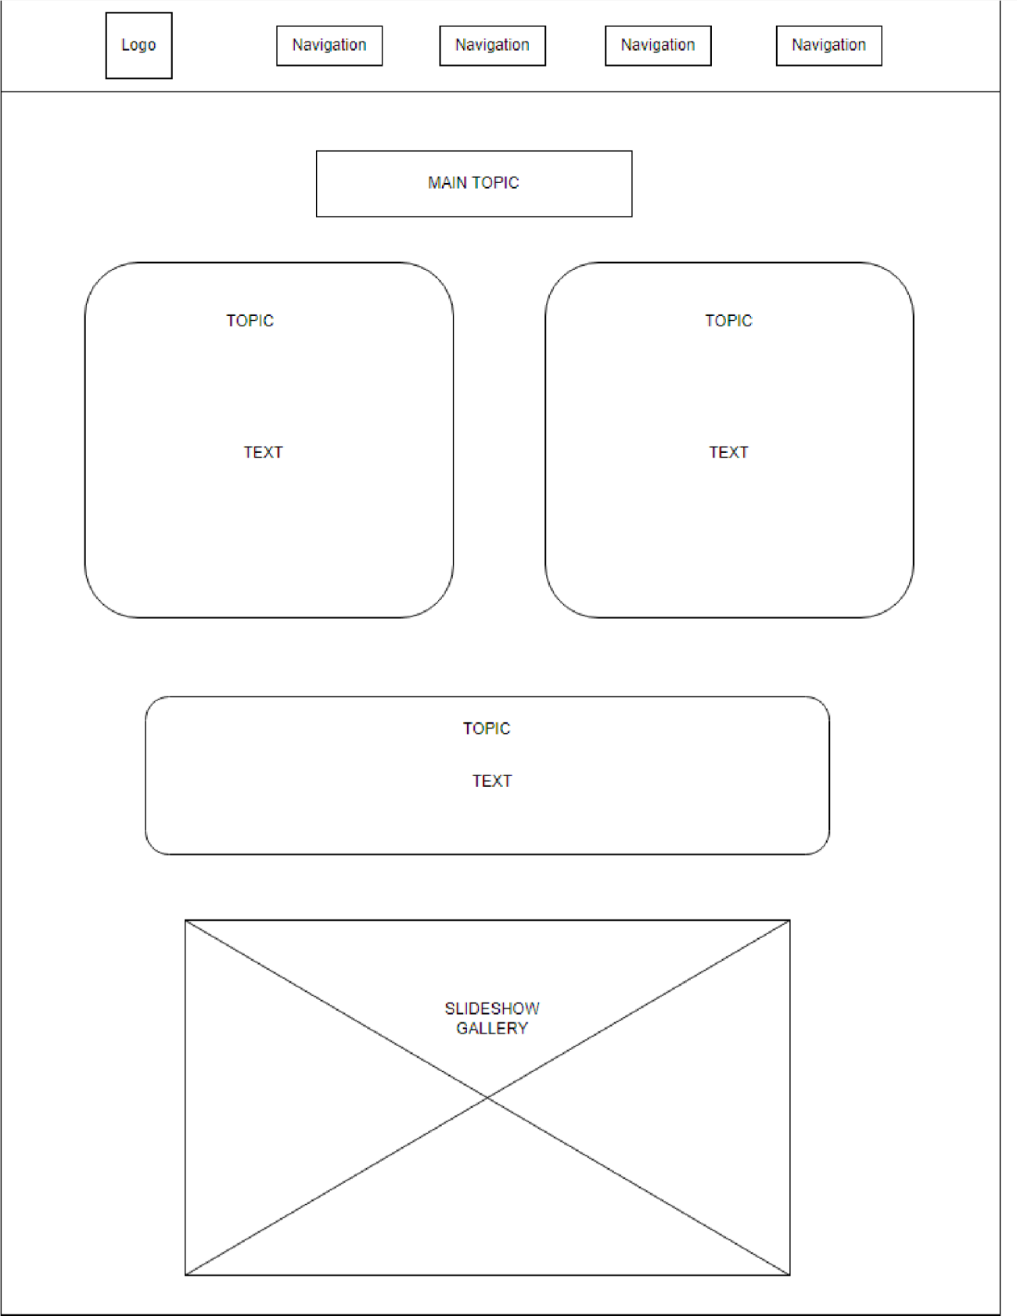

# wilpattupark.html – page 7

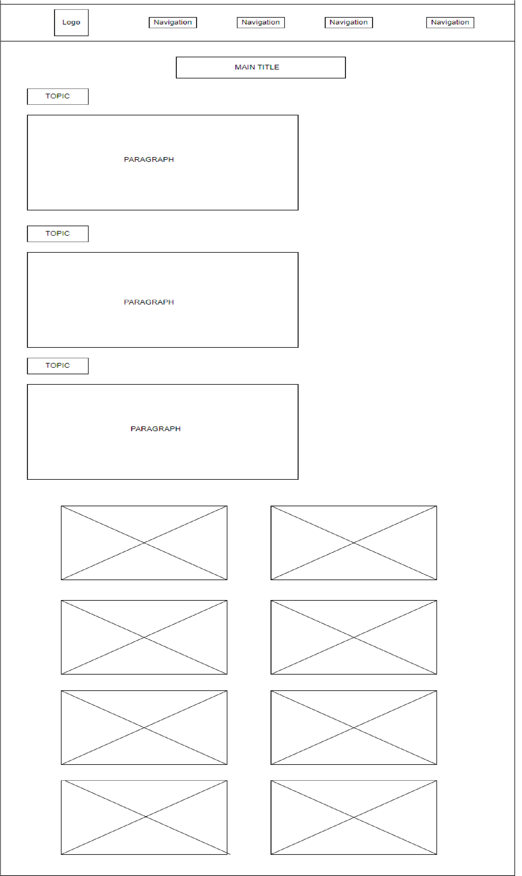

**WIREFRAMES-MOBILE DESIGN**

index.html- page 1



wildlifeintroduction.html

–

page 2



-

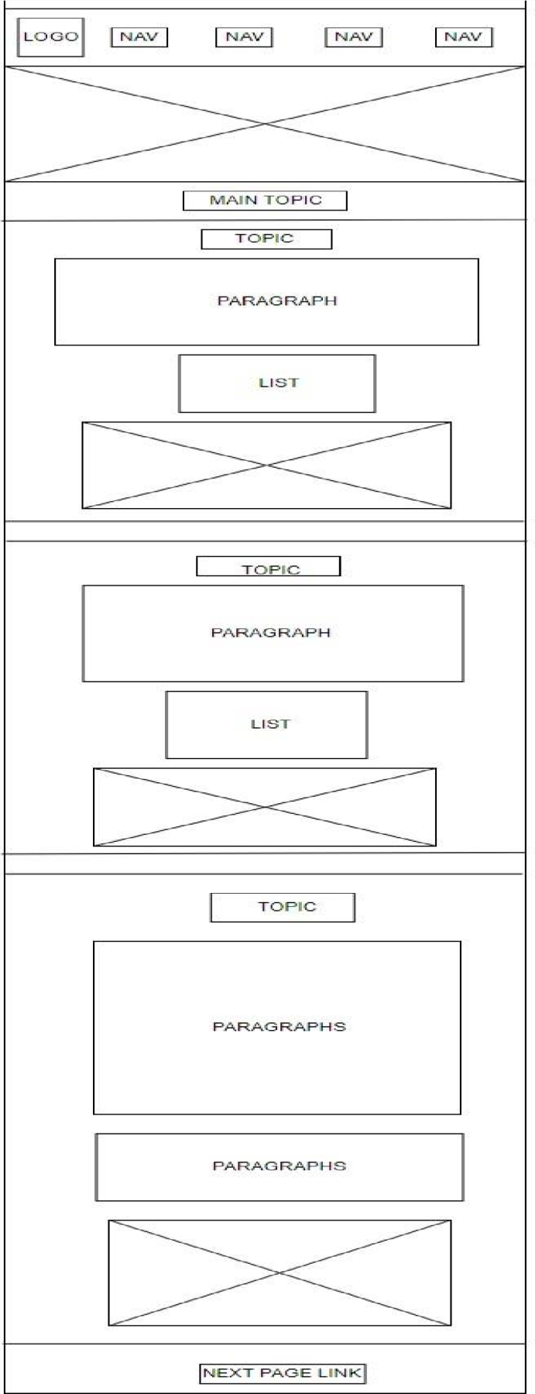

depwildlifecon.html

–

page 3



-

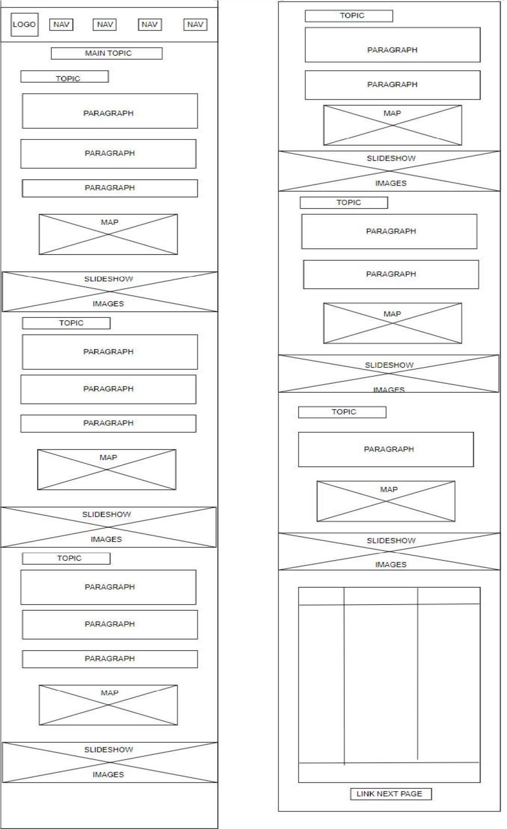

leopard.html

-

page 4



-

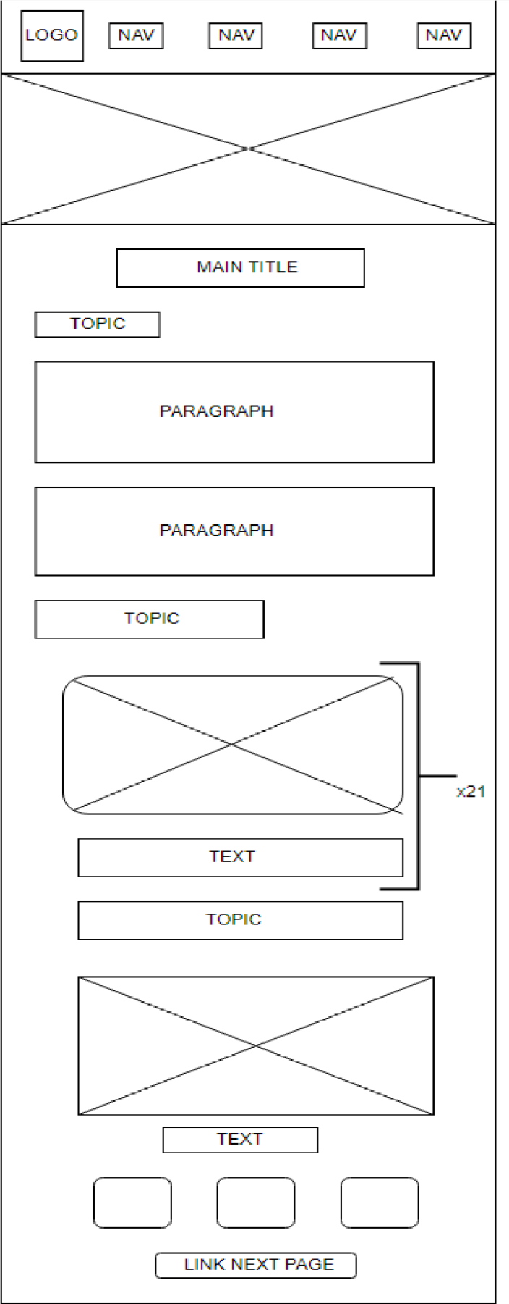

animalsinsrilanka.html

–

page 5



-

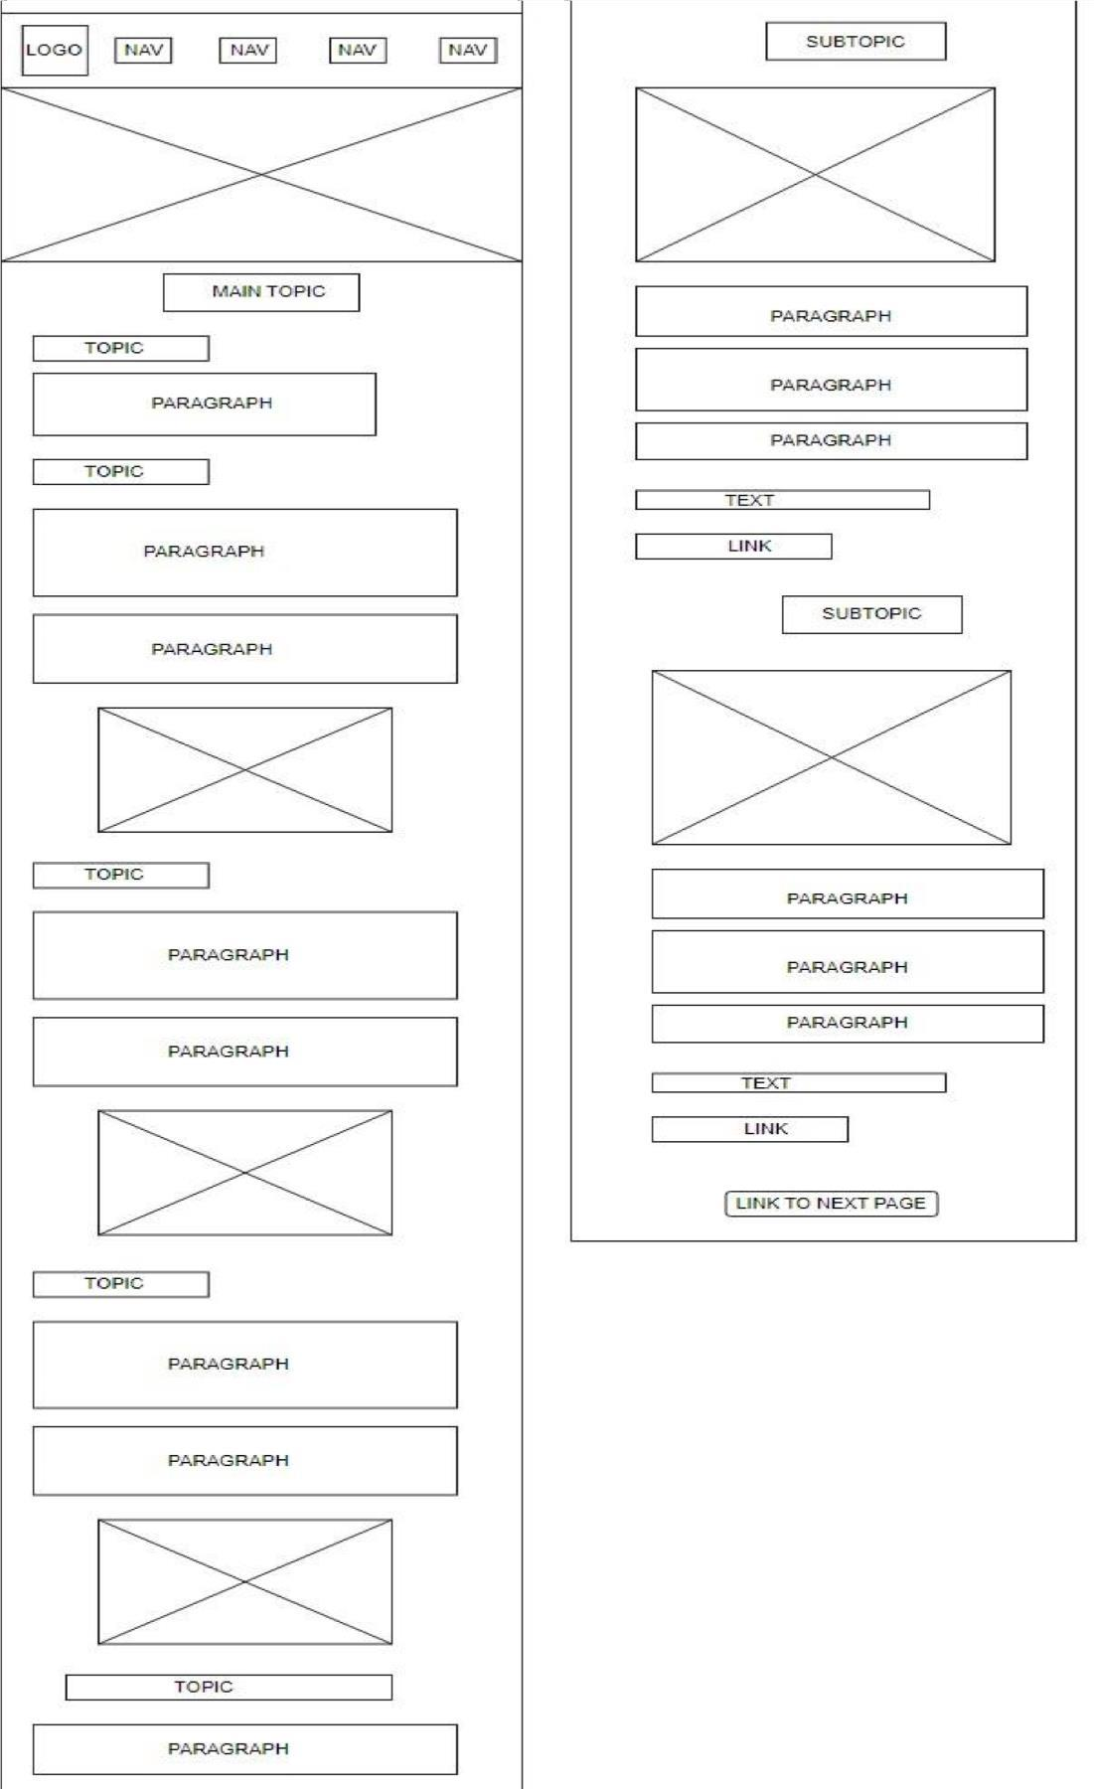



yalapark.html – page 6

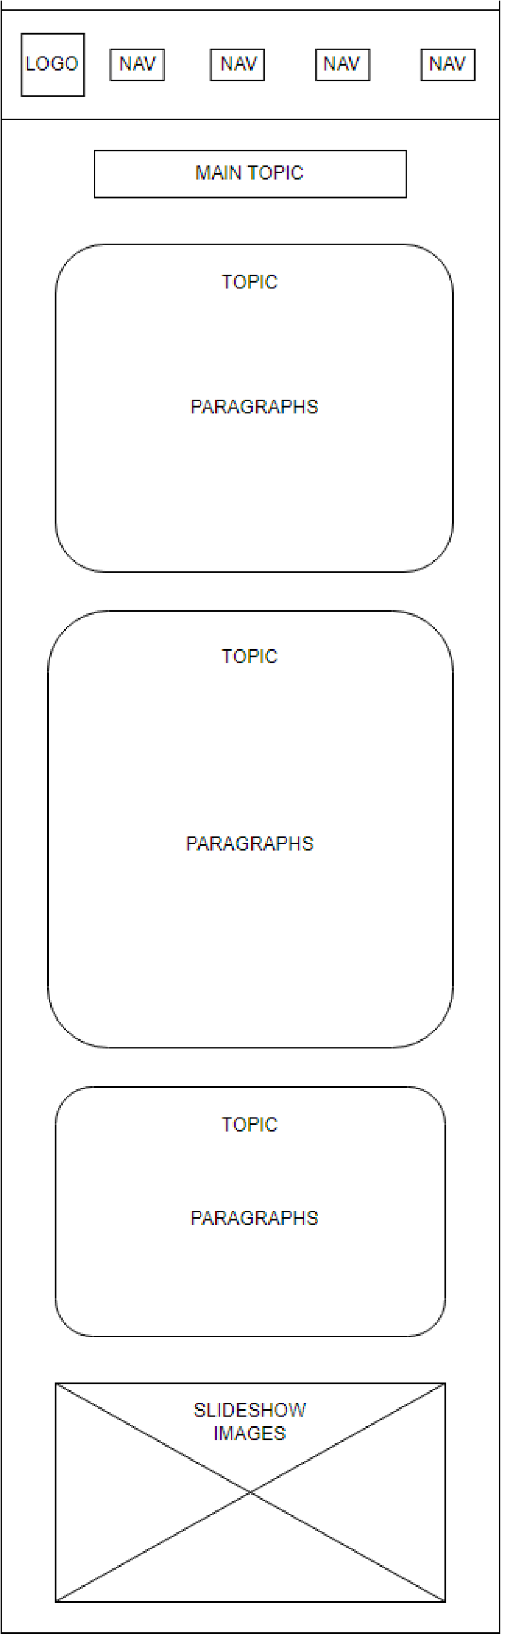

wilpattupark.html – page 7

